**Error while submitting the SOR to GCP. ( CCID issue)**

**Issue Description:** Unable to submit EZ SOR due to the following error " Error submitting to GCP"- AF SOR # 1-6612X77  
Error sending to DBOR. Please retry again or contact eCRM Help Desk

Reference ROME IE’s: 269999780, 267041744

**Troubleshooting and Resolution:**

cci.PARTY_SALES is the table in the GCP which gets loaded via SAART. sometimes it will store the Siebel row id at two diff levels in the table which will be inputted by SAART.

Hance when user tries to submit the SOR via ROME we get an error in the SetSPP transaction.

That is because GCP returns two CCID’s for the

<ns2:ForeignEcrmAccountId>1-3HUDY-280</ns2:ForeignEcrmAccountId>

Tag sent in the request of SetSPP.

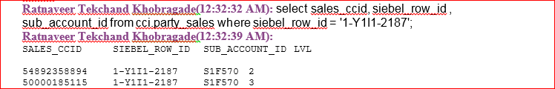

Above SS shows two records for the same Siebel_ Row_id i.e. tow CCID’s at stored at tow diff levels.

Which causes the issue in SOR submission. This is design gap at GCP side. GCP does not know which row to return when the request comes and it throws an error.

Below are the XML’s for example.

Akash Pankar(8:57:58 PM): <http://zlpv7059.vci.att.com:2220/RWS_out/SolutionInsertUpdateService/setSolutionProjectPackage/20170320_180936__1779_PS_fault.xml>  
Akash Pankar(8:58:16 PM): <http://zlpv7059.vci.att.com:2220/RWS_out/SolutionInsertUpdateService/setSolutionProjectPackage/20170320_180936__1779_PSReq.xml>

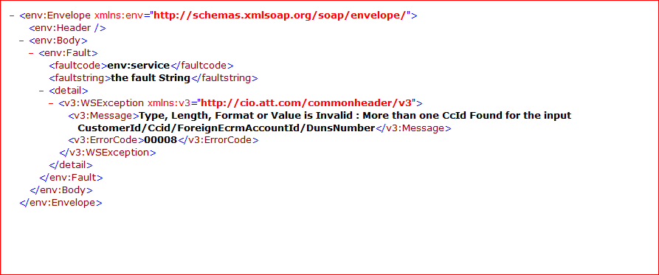

**George Goldberger**(4:12:56 PM): I need some clarifications from Business:  
1 - if same siebel is associated to account_id, sub_account_id and location, is to be returned?  
2. if same siebel is associated to account_id and location_id, which sales_ccid is to be returned?  
3. if same siebel is associated to sub_account_id and location_id, which sales_ccid should is to be returned?  
Can we use as general rule that in all the above cases will be returned based on these priority precedence: sub_account_id, location_id and account_id?  
  
Depending of the answers to the above questions, there may be an easy fix (just SQL returning the sales_ccid) or an AI redesign.

**George Goldberger(12:35:48 AM):** CCI is GCP/EDF...so, the changes need to be don,

correctly said, in CCI to return what is expected...the point is that there are 2 ways to do it:

by modifying the interface and adding the account level (or something similar) or to create a

rule that would be just a SQL modification....but for any of them we need a project/CR and

for the 2nd option (SQL) we need the blessing from business/architect

Above are the comments from GCP SE. it needs SQL in the API to return the correct CCID depending on the above points mentioned.

**Per Harish from COE** team this is GCP design Gap and GCP Provides WA for this.

Below is example of script they use for WA.

**Update cci.PARTY_SALES set SIEBEL_ROW_ID = null where saart_id = '9028026808';**

Once the GCP update gets completed we need to ask user to submit the SOR again which will

result in successful submission of it.

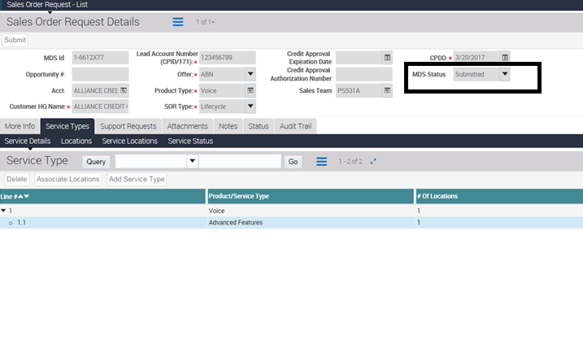

Above is the ss after the SOR submission done after the GCP WA. Before that MDS status Field will

be contain a text as **error.**